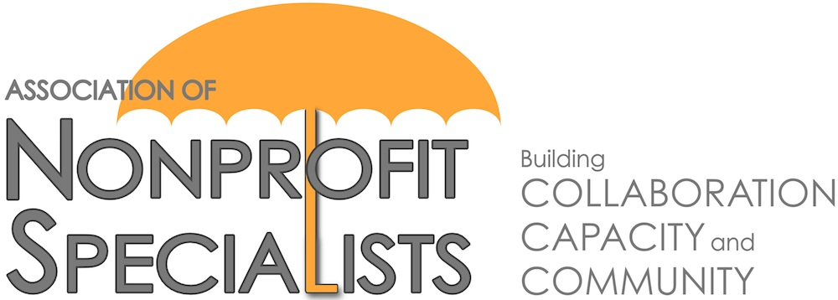
Partnership with Foundation Center:
Announcement about 2018 Facilitator Opportunities

The Association of Nonprofit Specialists is pleased to announce that the Foundation Center has once again asked us to help coordinate educational workshops for its constituents.

These 90-minute pro-bono sessions will be held throughout 2018, and typically attract 30-50 nonprofit professional attendees.

Here is what some past facilitators from our network had to say about their experience:
“Presenting at the Foundation Center was not only a completely enjoyable experience, but as a consultant it produced a lot of attention for my services and expertise. Almost immediately, I secured a very prominent nonprofit as a client to build a major gift program and we continue to work together to this day.” – Peter Heller, Peter J. Heller Consulting
“Working with ANS has opened me up to a valuable business development opportunity. As a result of speaking at the Foundation Center, I have been able to further my relationship with this established nonprofit service provider, while also introducing my work to a completely new group of people. Since the workshop I’ve already had several requests for assistance and follow-up with a couple of serious business connections.” – Bruce Arbit, Melarbit Partners
“I thoroughly enjoyed my session teaching under the auspices of the ANS/Foundation Center. The participants represented a wide range of organizations, experience and interest. They were enthusiastic, asked excellent questions, and demonstrated a high level of engagement. I would absolutely do it again.” – Marian Z. Stern, Projects in Philanthropy
If you are interested in being considered for this opportunity and are a member of the Association of Nonprofit Specialists, please complete the attached proposal and send it back to program@npspecialists.org by Wednesday, February 7, 2018.
IMPORTANT DETAILS:
- Topics: Your proposed session topic must fall into one or more of these categories: (1) Identifying new donors, (2) Moving existing donors up the pyramid (from small to mid-level to major), (3) Tactics for how to ask for money, (4) Using fundraising analytics, (5) Using data to attract donors, (6) Recruiting, retaining, and building a strong development staff.
- Dates: The 2018 session dates are May 16, July 11, and September 12. You must be available on one or more of these dates to be considered.
- Times: Sessions will run from 10:00 - 11:30AM.
- Location: Sessions will be held at the Foundation Center in downtown Manhattan at 32 Old Slip, 24th Floor, New York, NY 10005-3500.
- Review Process: Proposals will be reviewed by a sub-committee of the Association of Nonprofit Specialists, as well as staff from the Foundation Center.
- Notification: Applicants will be notified of the decisions by early March.

Please contact program@npspecialists.org with any questions.
2018 Foundation Center Facilitator Proposal

This proposal is due Wednesday, February 7, 2018. Submit to program@npspecialists.org. Submit one form per proposed session. Do not exceed this page or include additional documents or you may not be considered.

Your Name:
Company Name:
Are you a member of Nonprofit Specialists?
(this opportunity is for members only)
Company Website:
Your Email:
Professional Area(s) of Expertise:
Proposed Session Title:
Related Topic Area(s) (Delete those that are not relevant): | (1) Identifying new donors, (2) Moving existing donors up the pyramid, (3) Tactics for how to ask for money, (4) Using fundraising analytics, (5) Using data to attract donors, (6) Recruiting, retaining, and building a strong development staff
Brief Description of Session:
Proposed Agenda for Session:
On which session date(s) are you available? | ___ May 16 ___ July 11 ___ September 12
Names & Companies of Others You Plan to Include as Facilitators (if applicable):
Have you facilitated this session before?
If so, when and where?
Have you facilitated any other workshops before? If so, when and where?
Name, Role & Contact Info for 2 References that can attest to your facilitation skills:
Additional Information (optional):

