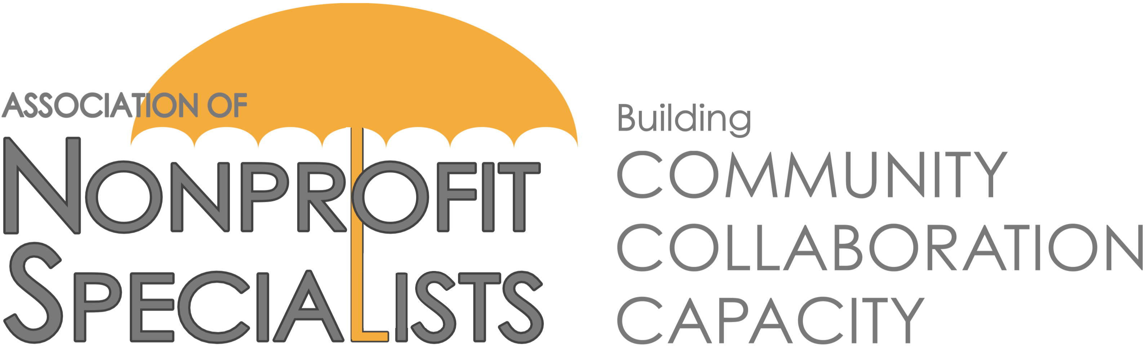
Partnership with Foundation Center:
Announcement about 2019 Facilitator Opportunities

The Association of Nonprofit Specialists is pleased to announce that the Foundation Center has once again asked us to help coordinate educational workshops for its constituents.

These 90-minute pro-bono sessions will be held throughout 2019, and typically attract 30-50 nonprofit professional attendees.

Here is what some past facilitators from our network had to say about their experience:
“I thoroughly enjoyed my session teaching under the auspices of the ANS/Foundation Center. The participants represented a wide range of organizations, experience and interest. They were enthusiastic, asked excellent questions, and demonstrated a high level of engagement. I would absolutely do it again.” – Marian Z. Stern, Projects in Philanthropy
“Presenting at the Foundation Center was not only a completely enjoyable experience, but as a consultant it produced a lot of attention for my services and expertise. Almost immediately, I secured a very prominent nonprofit as a client to build a major gift program and we continue to work together to this day.” – Peter Heller, Peter J. Heller Consulting
“Working with ANS has opened me up to a valuable business development opportunity. As a result of speaking at the Foundation Center, I have been able to further my relationship with this established nonprofit service provider, while also introducing my work to a completely new group of people. Since the workshop I’ve already had several requests for assistance and follow-up with a couple of serious business connections.” – Bruce Arbit, Melarbit Partners
If you are interested in being considered for this opportunity and are a member of the Association of Nonprofit Specialists, please complete the attached proposal and send it back to program@npspecialists.org by 5PM on Monday, January 28, 2019.
IMPORTANT DETAILS:
- Topics: Your proposed session topic must fall into one or more of these categories: (1) online fundraising, (2) corporate philanthropy, (3) earned income/diversifying funding streams, (4) staffing (how to decide when to hire development staff, which roles to add to a small team, recruitment/retention ideas), (5) getting on the radar of donor-advised funds, (6) nonprofit publicity (how to raise an organization’s profile).
- Dates: The 2019 session dates are May 8, July 18, and September 19. You must be available on one or more of these dates to be considered.
- Times: Sessions will run from 10 – 11:30AM.
- Location: Sessions will be held at the Foundation Center in downtown Manhattan at 32 Old Slip, 24th Floor, New York, NY 10005-3500.
- Membership: Facilitators must be current members of the Association of Nonprofit Specialists.
- Review Process: Proposals will be reviewed by a sub-committee of the Association of Nonprofit Specialists, as well as staff from the Foundation Center.
- Notification: Applicants will be notified of the decisions by mid-March.
- Contact: Please contact program@npspecialists.org with any questions.
2019 Foundation Center Facilitator Proposal

This proposal is due by 5PM on Monday, 1/28/19. Submit to program@npspecialists.org. Submit one form per proposed session. Do not exceed this page or include additional documents or you may not be considered.

Your Name:
Company Name:
Company Website:
Your Email:
Current member of Nonprofit Specialists?:
Professional Area(s) of Expertise:
Proposed Session Title:
Related Topic Area(s) (Use list on previous page):
Brief Description of Session:
Proposed Agenda for Session:
On which session date(s) are you available? (May 8, July 18, September 19)
Names & Companies of Others You Plan to Include as Facilitators (if applicable):
Have you facilitated this session before? If so, when and where?
Have you facilitated any other workshops before? If so, when and where?
Name, Role & Contact Info for 2 References that can attest to your facilitation skills:
Additional Information (optional):

