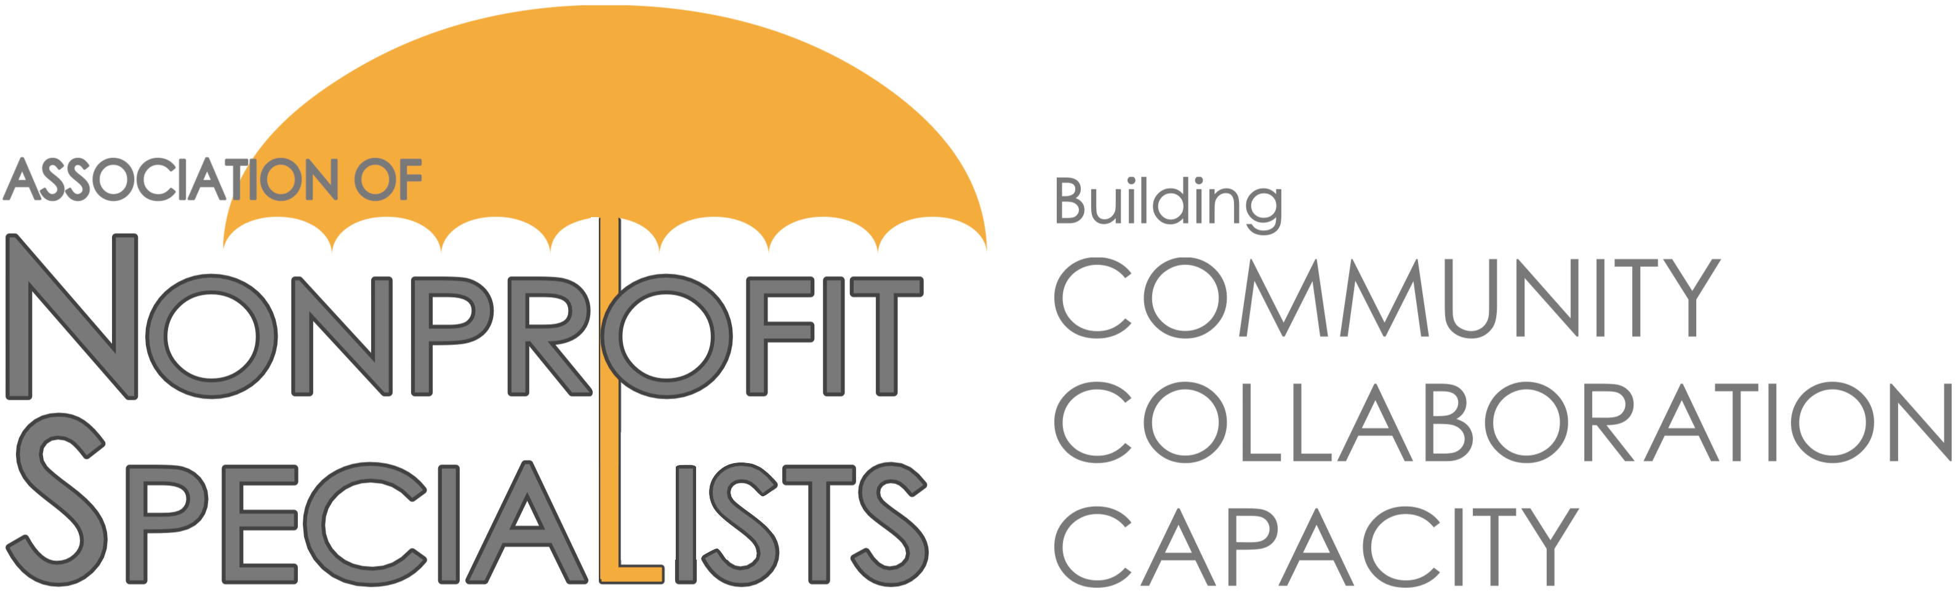
Announcement about 2021 Facilitator Opportunities with Candid

The Association of Nonprofit Specialists is pleased to announce Candid has once again asked us to help coordinate educational sessions for its constituents.

These 90-minute pro-bono webinars will be held throughout 2021, and typically attract 50+ nonprofit professional attendees from the New York / Northeast Region.

Here is what some past facilitators from our network had to say about their experience:
“The partnership between Nonprofit Specialists and Candid provides a great forum for presenting fresh ideas and having some thought-provoking conversation. The room is always packed with nonprofit professionals focused on gathering knowledge, developing skills, and building their organizations’ capacity to deliver on their mission.” – Jay Weisman, Legacy Philanthropy Group
“Presenting…was not only a completely enjoyable experience, but as a consultant it produced a lot of attention for my services and expertise. Almost immediately, I secured a very prominent nonprofit as a client to build a major gift program and we continue to work together to this day.” – Peter Heller, Peter J. Heller Consulting
“Working with Nonprofit Specialists and Candid on this session allowed me to show current and potential new clients how corporate approaches can benefit nonprofits without overwhelming already tapped staffs. The team worked with me to make a condensed workshop go off seamlessly including hands-on participation. Facilitating sessions like this one are an excellent way for me to showcase the high value services we provide. Thank you!!!" – Robin Yates, Yates Advisory LLC

If you are interested in being considered for this opportunity and are a member of Nonprofit Specialists, please complete the attached proposal and send it back to info@ npspecialists.org by 5PM on Thursday, January 28, 2021.
IMPORTANT DETAILS:
- Topics: Your proposed session topic must be relevant to nonprofits in the NYC / Northeast Region, touch upon current trends and realities, and fall into one or more of these categories: (1) volunteer management, (2) work culture, (3) event management, (4) risk management, (5) scenario planning, (6) scaling / offering programs virtually.
- Dates & Times: The 2021 session dates are May 4, July 27, and September 21. All sessions will run from 10:00–11:30AM. You must be available on one or more of these dates to be considered.
- Location: Sessions will be held via Zoom. Facilitators should have prior experience with and feel comfortable using this platform.
- Membership: Facilitators must be current members of the Association of Nonprofit Specialists.
- Review Process: Proposals will be reviewed by a sub-committee of Nonprofit Specialists, as well as staff from Candid.
- Notification: Applicants will be notified of the decisions by mid-March.
- Contact: Please contact info@npspecialists.org with any questions.
2021 Foundation Center Facilitator Proposal

This proposal is due by 5PM on Thursday, January 28, 2021. Submit to info@npspecialists.org. Submit one form per proposed session. Do not exceed this page or include additional documents or you may not be considered. If selected, you will be asked to coordinate directly with Candid to finalize your session description, content and materials.

Your Name:
Company Name:
Company Website:
Your Email:
Current member of Nonprofit Specialists?:
Professional Area(s) of Expertise:
Proposed Session Title:
Related Topic Area(s) (Use list on previous page):
Brief Description of Session:
Proposed Agenda for Session:
On which session date(s) are you available? (May 4, July 27, September 21)
Names & Companies of Others You Plan to Include as Facilitators (if applicable):
Have you facilitated this session before? If so, when and where?
Have you facilitated any other workshops before? If so, when and where?
Name, Role & Contact Info for 2 References that can attest to your facilitation skills:
Additional Information (optional):

