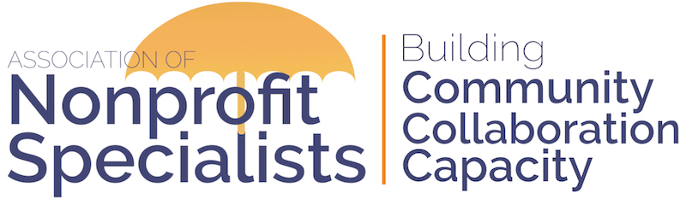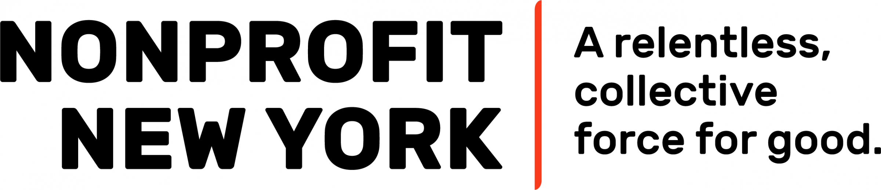
Announcement about 2021 Facilitator Opportunities with Nonprofit New York

The Association of Nonprofit Specialists is pleased to announce a new partnership with Nonprofit New York to help coordinate educational sessions for its constituents.

These 90-minute pro-bono webinars will be held from October to December, 2021, and will be offered to Nonprofit New York’s network of organizations (free to Nonprofit New York’s members, at low cost to non-members) as part of its slate of trainings.

If you are interested in being considered for this opportunity and are a member of Nonprofit Specialists, please complete the attached proposal and send it back to info@npspecialists.org by 5PM on Monday, August 16, 2021.
IMPORTANT DETAILS:
- Topics: Your proposed session topic must be relevant to nonprofits in the NYC metropolitan area, touch upon current trends and realities, and fall into one or more of these Key Areas of Nonprofit Excellence: advocacy and strategic alliances; communications; diversity, equity, and inclusion; financial management; fundraising and resource development; governance; human resources; planning and evaluation; and technology and data use. Topics of particular interest include DEI, disaster planning, and cybersecurity.
- Dates & Times: The session dates are: October 5, 12, 19, 26; November 2, 9, 16, 30; and December 14. All sessions will run from 10:30AM–12:00PM. You must be available on one or more of these dates to be considered.
- Location: Sessions will be held via Zoom. Facilitators should have prior experience with and feel comfortable using this platform.
- Non-Solicitation: Facilitators agree to observe Nonprofit New York’s non-solicitation policy: Nonprofit New York’s educational Presentations are learning experiences and are thereby non-commercial. Although Presenters are welcome to provide contact information and distribute basic information about their organization or firm, or to mention an offering as an incidental part of a larger Presentation, under no circumstances should a session or be used as a forum for direct promotion of a Presenter’s products or services for monetary self-interest. Only 4% or less of the total Presentation should be devoted to basic information about your organization or firm.
- Membership: Facilitators must be current members of the Association of Nonprofit Specialists.
- Review Process: Proposals will be reviewed by a sub-committee of Nonprofit Specialists, as well as staff from Nonprofit New York.
- Notification: Applicants will be notified of the decisions by early September.
- Contact: Please contact info@npspecialists.org with any questions.

2021 Nonprofit New York Facilitator Proposal

This proposal is due by 5PM on Monday, August 16, 2021. Submit to info@npspecialists.org. Submit one form per proposed session. Do not exceed this page or include additional documents or you may not be considered. If selected, you will be asked to coordinate directly with Nonprofit New York to finalize your session description, content and materials.

Your Name:
Company Name:
Company Website:
Your Email:
Current member of Nonprofit Specialists?:
Professional Area(s) of Expertise:
Proposed Session Title:
Related Topic Area(s) (Use list on previous page):
Brief Description of Session:
Session Takeaways: (List at least three key takeaways that attendees will learn.)
Proposed Agenda for Session:
On which session date(s) are you available? (October 5, 12, 19, 26; November 2, 9, 16, 30; and December 14)
Names & Companies of Others You Plan to Include as Facilitators (if applicable):
Have you facilitated this session before? If so, when and where?
Have you facilitated any other workshops before? If so, when and where?
Name, Role & Contact Info for 2 References that can attest to your facilitation skills:
Additional Information (optional):

