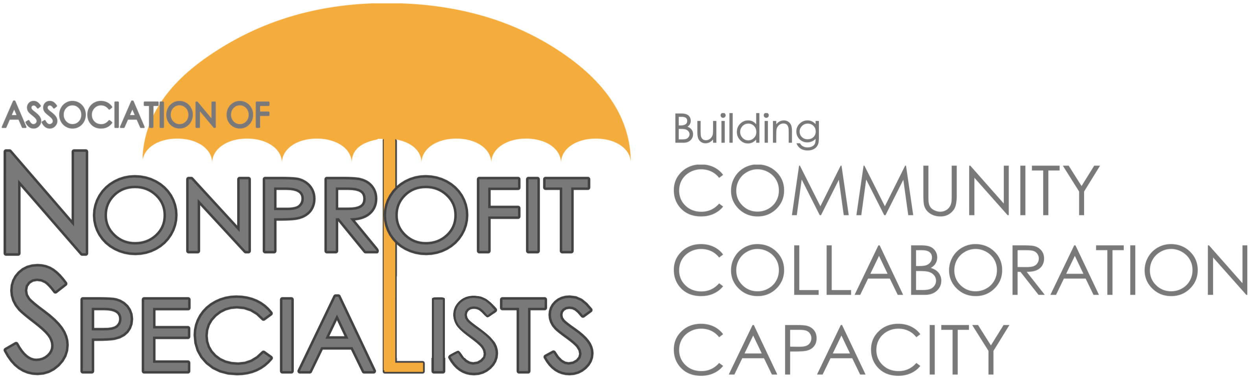
Announcement about 2022 Q4 Facilitator Opportunities with Nonprofit New York

The Association of Nonprofit Specialists is pleased to announce Nonprofit New York has once again asked us to help coordinate educational sessions for its constituents.

These pro-bono webinars will be held on Tuesdays from October - December 2022. They can vary in length (60-min, 90-min, 120-min), and typically attract 50+ nonprofit professional attendees from the Greater New York area.

If you are interested in being considered, did not serve as a facilitator during the 2022 Q2 Nonprofit New York series, and are a member of Nonprofit Specialists, please submit the attached proposal to info@ npspecialists.org by 5PM on Monday, August 22, 2022.
IMPORTANT DETAILS:
- Eligibility: Facilitators must be current members of the Association of Nonprofit Specialists who did not present as part of the Nonprofit New York series in 2022 Q2.
- Topics: Session topics must fall within one of Nonprofit New York’s Key Areas of Nonprofit Excellence: Fundraising, Financial Management, Planning & Evaluation, Human Resources, Governance, Technology, Diversity, Equity & Inclusion, Communications, Advocacy
  - NOTE: In Q4, special priority will be given to sessions that address these in-demand topics: (1) Human Resources (especially hybrid policies, compliance), (2) Fundraising (especially without galas, hybrid/online, in this new world), (3) Planning and evaluation (especially with dEIA practices), (4) Volunteer management (accountability), (5) Communications
- Dates & Times: Sessions will be offered on Tuesdays starting at 10AM from October 4 through December 13. You must be available on one or more of these dates.
- Location: Sessions will be held via Zoom. Facilitators should have prior experience with and feel comfortable using this platform.
- Nonprofit New York Policies: Those selected to present will be asked to sign an agreement with Nonprofit New York, which will include details on their Non-Solicitation and Code of Conduct policies, as well as their Presenter deadlines & Expectations.
- Association of Nonprofit Specialists Policies: Those selected to present will be asked to include a brief overview of Nonprofit Specialists at the beginning of their session (slides and talking points will be provided).
- Review Process: Proposals will be reviewed by a sub-committee of Nonprofit Specialists, as well as staff from Nonprofit New York.
- Notification: Applicants will be notified of the decisions by mid-September 2022.
- Contact: Please contact info@npspecialists.org with any questions.

2022 Q4 Nonprofit New York Facilitator Proposal

This proposal is due by 5PM on Monday, August 22, 2022. Submit to info@npspecialists.org. Submit one form per proposed session. Please limit your proposal to just the questions outlined. If selected, you will be asked to coordinate directly with Nonprofit New York to finalize your session description, content and materials.

Your Name:
Your Title:
Company/Organization Name:
Company/Organization Website:
Your Phone Number:
Your Email:
Current member of Nonprofit Specialists?:
Co-Presenter Name (if applicable):
Co-Presenter Title:
Co-Presenter Company/Organization Name:
Co-Presenter Phone Number:
Co-Presenter Email Address:
Proposed Session Title:
Training Session Description:
- (as it would appear on NNY’s training calendar; explain purpose, target audience, etc., 150 words)
Training Summary:
- (brief, used in marketing materials, 140 characters)
3-4 Key Take-Aways:
- (also for online description, highlight key learnings)
Related Key Area(s) of Excellence:  - (indicate which area/s this session connects to) | - Fundraising, Financial Management, Planning & Evaluation, Human Resources, Governance, Technology, Diversity, Equity & Inclusion, Communications, Advocacy
Proposed Agenda for Session:
Technology Support Needs:  (indicate what kind of Zoom support you need) | Polls, breakout rooms, chat monitoring, other
Materials/Handouts:
(What resources, handouts, PPTs, or materials will you provide to augment learning?)
Session Length:  (indicate your preferred session length) | 60 minutes, 90 minutes, 120 minutes
On which session date(s) are you available?  (indicate your preferred dates) | Oct 4, Oct 11, Oct 18, Oct 25, Nov 1, Nov 8, Nov 15, Nov 22, Nov 29, dec 13
Have you facilitated this session before? If so, when and where?
Have you facilitated any other workshops before? If so, when and where?
Name, Role & Contact Info for 2 References that can attest to your facilitation skills:
Brief Bio(s):

